

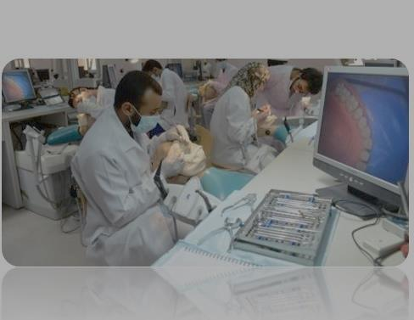

**Fellowship in Oral and Maxillofacial Surgery**

**Department of Biomedical Dental Sciences**

**College of Dentistry**

**Imam Abdulrahman Bin Faisal University**

**Program name:** Fellowship

**Name of the degree awarded:** Fellowship in Oral and Maxillofacial Surgery

**Objectives of the program:**

By the end of the program, the graduate should be able to:

1. Manage patients with simple and complex oral and maxillofacial conditions.

2. Teach undergraduate dental students both the theoretical and clinical components of different oral surgery courses.

**Justification for the program’s provision:**

The rationale for the establishment of the Fellowship program can be summarized as follows:

1. The expansion and depth of knowledge, advancement in technology and breadth of clinical skills required in dentistry has rapidly surpassed the scope of the general dental practice. As in many fields of medicine, specialization in different areas of dentistry is a requirement at our college to mirror the levels of education currently provided at other leading universities worldwide.

2. As a leading institute providing graduate training in the Eastern Province, the Fellowship program will enable the college to expand the levels and quality of dental services currently being provided.

3. The availability of oral and maxillofacial surgery services at specialist level will reduce the waiting times for patients in need of complex treatment.

4. The Program will stimulate the Saudi dental graduate living in the Eastern Province of Saudi Arabia to seek continuous professional development.

5. The program will also serve to fulfill the Kingdom vision 2030 by increasing the number of postgraduate programs and postgraduates. graduates

6. The program will improve the employability of graduate dentists in KSA.

**Study plan:**

The Fellowship in Oral and Maxillofacial Surgery program consists of a comprehensive, 5-year curriculum of full-time study composed of 10 academic semesters and summer semesters.

The curriculum has been designed to graduate students with an in-depth knowledge and the surgical skills required for the practice of Oral and Maxillofacial Surgery, prepare them for teaching and provide them with experience and training in research methods. To achieve these goals students will work in an exciting and contemporary educational environment, making the best use of technology and advances in teaching methodologies.

Students will participate in teaching Oral and Maxillofacial Surgery to undergraduate dental students. Their teaching experience will commence in their second year of the program after they have completed Year 1 and demonstrated they have acquired the necessary foundational knowledge of OMFS. Teaching challenges students and allows them to identify their strengths and weaknesses both didactically and clinically. Teaching also improves students’ understanding of the concepts and practices integral to the specialty. In addition, the experiences gained from teaching also help students to learn how to transfer their knowledge of theory and practices to undergraduate students, patients, fellow faculty and staff members all of which are essential for their profession growth and development.

**General overview of the program:**

The Fellowship in OMFS program can be described in the following year-by-year overview:

Year 1 – The program begins with training in the basic principles of OMFS and the management of medically compromised patients. It assesses the individual knowledge of students and calibrates their technical skills to the standards of the College of Dentistry. Core and specialty courses are provided along with clinical training. The student is familiarized to hospital-based practice and would participate in preoperative work ups, operative procedures, and postoperative care. He/she would be trained in the skills necessary to be the first on-call in OMFS emergencies.

Year 2 - Students will enroll in additional core and specialty courses, continue with advanced patient care in clinical courses and are introduced to advanced research through courses in research methodologies as well as biostatistics. Students are expected to begin their search for and selection of an appropriate research project by the end of the second year. A master level research project should be selected, prepared as a research protocol, and submitted for approval in this year.

Upon successful completion of the first 4 OMFS specialty course the student would start postings/rotations in the allied specialties with clear learning objectives and goals. The student would take on responsibilities including on call and patient care and management.

The rotation includes but is not limited to:

Internal Medicine rotation that includes hematology, general medicine, and cardiology. (2 Months)

Anesthesia, that includes training in IV Sedation, and general anesthesia. (3 Months)

General Surgery (1 month)

Emergency trauma (1 month)

Surgical intensive care (1 month)

Plastic surgery (1 month)

Neurosurgery (1 month)

Otolaryngology / ENT (1 month)

Ophthalmology (1 month)

Year 3 - At this stage in the program aside from completion of any remaining core and specialty courses, students will continue enrollment in research to complete their project by year’s end. Students will be required to prepare a manuscript and submit for publication. Also, in year 3 the students will enroll in special 1-hour courses, entitled Directed Study, to provide them with experience in a wide variety of areas related to dental education, teaching and research. The following is a partial list of topics from which students may select areas of interest: Accreditation, accreditation reporting, academic affairs, committee structure and management, clinic administration, competencies, electronic patient records, faculty development, faculty promotions, electronic educational media, interdisciplinary interaction (referrals), scientific writing, strategic planning, technology in dentistry and trends in dental education.

Students are expected to enroll in at least four (4) units of directed study course per academic year (2 units per semester) with the approval of the supervising faculty member and the proposed plan for each term by the Program Director.

During this year students would be sent for training in areas of specialist interest within Oral and Maxillofacial Surgery. There would be 3 postings/rotations each of 2 months duration in which the student would be sent to high volume centers managing patients requiring (i) Head and Neck surgical oncology, (ii) Cosmetic and reconstructive surgery, (iii) Cleft lip and palate and craniofacial surgery.

Year 4 – In the fourth year, final year students will fulfill all remaining didactic core and specialty course requirements, take at least four (4) additional Directed Study courses, complete their clinical requirement (by the end of the academic year) and submit proof of acceptance or published article from their research project in a peer-reviewed journal.